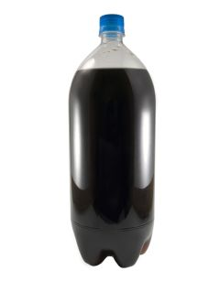
2 Liter Soda Bottle
Person
(Due by Oct-12th)
For this project, you will be creating a character using a 2- liter bottle.

First- Read your chapter book.
Next- You will decorate the bottle like the character. If you don’t know what your character looks like, use what you read in the story to create a mental image of what you think he or she looks like.
Then- Write your character’s name. Include your favorite quote from the character. Write a short paragraph describing the character. (What they look like, their feelings, how they change over time.)
Finally- Present your character bottle and paragraph to the class.

