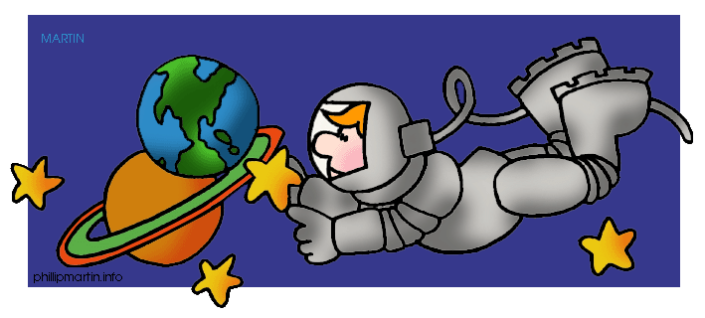
Dear Parents,

This week, we have been talking about the solar system. Your child has chosen the planet ___________________________________
to complete a report on. The report needs to include
5-7 (or more!) facts about the planet. They can make a poster, draw a picture, or design a model of their planet to go along with their report. If you do not have internet access and need information about your planet, please let me know and I can get information for the child to use. All projects are due on Monday, August 26th.

Thank you for all you do!!
Mrs. Cassandra

